
Kevin Colburn
National Stewardship Director
1035 Van Buren Street
Missoula, MT 59802
406-543-1802
www.americanwhitewater.org kevin@amwhitewater.org

July 17, 2007

Attn: Director - Idaho Department of Lands
Secretary to the State Board of Land Commissioners
954 West Jefferson
Post Office Box 83720
Boise, Idaho 83720-0050
Dear Director,
American Whitewater is a national nonprofit organization whose mission it to protect and restore our nation’s whitewater resources while enhancing opportunities to enjoy them safely. We have roughly 6,800 members, a significant portion of which live in – or recreate in – Idaho. We are writing you today regarding a proposed mine along and in the Salmon River upstream of Lucile, Idaho that your agency is currently considering.
We strongly encourage you to reject this proposed mine outright. Mining along and/or in the Wild and Scenic eligible and suitable Salmon River would have unacceptable ecological and biological impacts. It seems impossible that such mining could occur without introducing water pollution to the river and impacting river substrate and dynamics. The activities associated with mining would also have significantly impact the recreational quality of paddling the Salmon River. Our members cherish the type of scenic paddling experience that the entire Salmon River provides, and a mine would seriously detract from this experience.
Please do not allow a new mine to impact the Salmon River.
Thank you for considering our interests.
Sincerely,
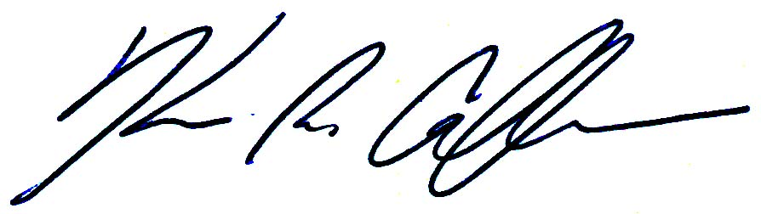
Kevin Colburn

