January 7, 2009

Magalie R. Salas, Secretary
Federal Energy Regulatory Commission
888 First Street, N.E.
Washington, D.C. 20426

RE: COMMENTS of American Whitewater on the proposed Palomar Liquefied Natural Gas (LNG) Pipeline (Docket PF07-13-000).

Dear Secretary Salas:

Enclosed for filing in the above-referenced proceeding are Comments by American Whitewater on the proposed Palomar Liquefied Natural Gas (LNG) Pipeline.

Interest of American Whitewater

American Whitewater is a national non-profit 501(c)(3) river conservation organization founded in 1954. We have over 6,500 members and 100 local-based affiliate clubs, representing approximately 80,000 whitewater paddlers across the nation. American Whitewater’s mission is to conserve and restore America’s whitewater resources and to enhance opportunities to enjoy them safely. As a conservation-oriented paddling organization, American Whitewater has an interest in the Deschutes and Clackamas Wild and Scenic Rivers as well as the other rivers and creeks in the Mt. Hood National Forest that would be impacted by the proposed pipeline. A significant percentage of American Whitewater members reside in the communities surrounding Mt. Hood and utilize these rivers for recreational enjoyment.

Comments of American Whitewater

The proposed route crosses the Wild and Scenic Clackamas and Deschutes Rivers. In both cases the proposal is inconsistent with the Wild and Scenic Rivers Act and will have detrimental impacts on the outstanding remarkable value of these rivers. The Deschutes River and Clackamas River are both highly valued for the recreational opportunities they provide to our members. The overhead crossing on the Deschutes would result in a new bridge that would conflict with agency guidelines and the management plan requiring that outstanding remarkable values be maintained and improved. The open cut crossing across the Clackamas River and associated pipeline corridor through the riparian forest will negatively impact the values for which this river was designated. Based on the information currently on the record in this proceeding we do not support construction of this pipeline given the associated impacts to these Wild and Scenic Rivers and their recreational and aesthetic values as recognized under the Wild and Scenic Rivers Act.

Sincerely,
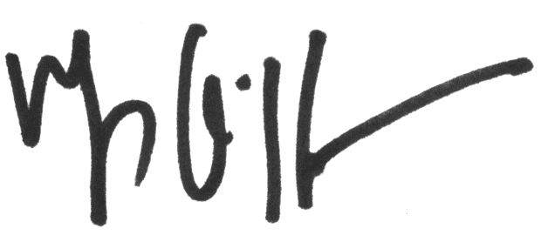
Thomas O’Keefe
Pacific Northwest Stewardship Director

cc:

Governor Ted Kulongoski
160 State Capitol
900 Court Street
Salem, OR 97301-4047

Senator Ron Wyden
1220 SW 3rd Avenue, Suite 585
Portland, OR 97204

Senator Jeff Merkley
3016 SE Division
Portland, Oregon 97202

Representative Kurt Schrader
607 North Main Street, Suite 240
Oregon City, OR 97045

Representative Greg Walden
131 NW Hawthorne, Suite 201
Bend, OR 97701

